ITM 311-02

Katherine Papademas

Erick Cabrera

December 08, 2016

**Purpose:** To create an easy-to-use ATM interface for customer to have a faster way to gain access to their account.

* Simple and straight-forward
* Able to set unique PIN
* Able to write checks from checking account and show balance
* Able to deposit and withdraw money to and from saving account and show balance
* Able to select any loan that you may have and make payments on them and show balance

**Client:** IIT Bank and Trust Company

3300 So. Federal, Chicago, IL 60616

**Source Code:**

**ATM class:**

import java.io.IOException;

import java.util.Objects;

public class ATM {

public static void main(String args[]) throws IOException {

Checking chkgAcct = new Checking(3000.00);

Savings svngAcct = new Savings(3000.00);

Mortgage mLoan = new Mortgage(250000.00);

Student sLoan = new Student(55000.00);

Auto aLoan = new Auto(45000.00);

Personal pLoan = new Personal(4000.00);

String PIN = "";

// set PIN

PIN = Display.inputDialog("********* IIT BANK AND TRUST COMPANY *********" + "\n" +

" Please set your 4-Digit PIN" + "\n" +

" (Between 0100 and 8888)");

int checkPIN = Integer.parseInt(PIN);

Boolean okPIN = checkPIN > 0100 && checkPIN < 8888;

if(!okPIN) {

PIN = Display.inputDialog(" The PIN is invalid. Please try again.");

checkPIN = Integer.parseInt(PIN);

okPIN = checkPIN > 100 && checkPIN < 8888;

}

Display.messageDialog(" PIN set. Thank you!");

// Login

String userPIN = Display.inputDialog(" Please enter your PIN to login.");

Boolean okLogin = Objects.equals(userPIN, PIN);

while(!okLogin){

userPIN = Display.inputDialog("The PIN you entered was incorrect. Please try again.");

okLogin = Objects.equals(userPIN, PIN);

}

// Account Access

while (true) {

String select = Display.inputDialog("Which account would you like to access?" + "\n" +

"c for Checking, s for Savings, or l for Loans");

// Checking Account

if (Objects.equals(select.toLowerCase(), "c")){

String selection = Display.inputDialog("************CHECKING ACCOUNT************" + "\n" +

" What would you lke to do?" + "\n" +

" w to Write a check, b to show Balance");

if (Objects.equals(selection.toLowerCase(), "w")) {

String check = Display.inputDialog("Please type the amount of the check.");

chkgAcct.Checks(Double.parseDouble(check));

chkgAcct.showBalance();

} else if (Objects.equals(selection.toLowerCase(), "b")) {

chkgAcct.showBalance();

} else {

Display.messageDialog("I'm sorry. I did not recognize your selection. Please try again.");

}

// Savings Account

} else if (Objects.equals(select.toLowerCase(), "s")) {

String selection = Display.inputDialog("************SAVINGS ACCOUNT************" + "\n" +

" What would you lke to do?" + "\n" +

"d for Deposit, w for Withdraw, or b for Balance");

if (Objects.equals(selection.toLowerCase(), "d")) {

String amnt = Display.inputDialog("How much would you like to deposit?");

svngAcct.deposit(Double.parseDouble(amnt));

svngAcct.displayBalance();

} else if (Objects.equals(selection.toLowerCase(), "w")) {

String amount = Display.inputDialog("How much would you like to withraw?");

svngAcct.withdraw(Double.parseDouble(amount));

svngAcct.displayBalance();

} else if (Objects.equals(selection.toLowerCase(), "b")) {

svngAcct.displayBalance();

} else {

Display.messageDialog("I'm sorry. I did not recognize your selection. Please try again.");

}

// Loans

} else if (Objects.equals(select.toLowerCase(), "l")) {

String loans = Display.inputDialog(" Which loan would you like to view?" + "\n" +

" m for Mortgage, s for Student, a for Auto," + "\n" +

" or p for Personal");

// Mortgage

if (Objects.equals(loans.toLowerCase(), "m")) {

String selection = Display.inputDialog("************MORTGAGE LOAN************" + "\n" +

" What would you lie to do?"+ "\n" +

" p for Payment or b for Balance");

if (Objects.equals(selection.toLowerCase(), "p")) {

mLoan.Payment();

mLoan.showBalance();

} else if (Objects.equals(selection.toLowerCase(), "b")) {

mLoan.showBalance();

} else {

Display.messageDialog("I'm sorry. I did not recognize your selection. Please try again.");

}

// Student

} else if (Objects.equals(loans.toLowerCase(), "s")) {

String selection = Display.inputDialog("************STUDENT LOAN************" + "\n" +

" What would you lie to do?"+ "\n" +

" p for Payment or b for Balance");

if (Objects.equals(selection.toLowerCase(), "p")) {

sLoan.Payment();

sLoan.showBalance();

} else if (Objects.equals(selection.toLowerCase(), "b")) {

sLoan.showBalance();

} else {

Display.messageDialog("I'm sorry. I did not recognize your selection. Please try again.");

}

// Auto

} else if (Objects.equals(loans.toLowerCase(), "a")) {

String selection = Display.inputDialog("************AUTO LOAN*************" + "\n" +

" What would you lie to do?"+ "\n" +

" p for Payment or b for Balance");

if (Objects.equals(selection.toLowerCase(), "p")) {

aLoan.Payment();

aLoan.showBalance();

} else if (Objects.equals(selection.toLowerCase(), "b")) {

aLoan.showBalance();

} else {

Display.messageDialog("I'm sorry. I did not recognize your selection. Please try again.");

}

// Personal

} else if (Objects.equals(loans.toLowerCase(), "p")) {

String selection = Display.inputDialog("************PERSONAL LOAN*************" + "\n" +

" What would you lie to do?"+ "\n" +

" p for Payment or b for Balance");

if (Objects.equals(selection.toLowerCase(), "p")) {

pLoan.Payment();

pLoan.showBalance();

} else if (Objects.equals(selection.toLowerCase(), "b")) {

pLoan.showBalance();

} else {

Display.messageDialog("I'm sorry. I did not recognize your selection. Please try again.");

}

} else {

Display.messageDialog("I'm sorry. I did not recognize your selection. Please try again.");

}

} else {

Display.messageDialog("I'm sorry. I did not recognize your selection. Please try again.");

}

}

}

}

**Display class:**

import javax.swing.*;

public class Display {

public static String inputDialog(String prompt) {

return JOptionPane.showInputDialog(null, prompt);

}

public static void messageDialog(String msg) {

JOptionPane.showMessageDialog(null, msg);

}

}

**Checking class:**

import javax.swing.*;

public class Checking {

double balance;

public Checking(double initBal){

balance = initBal;

}

public void Checks(double amnt) {

balance -= amnt;

}

;

public void showBalance(){

JOptionPane.showMessageDialog(null, "Balance is: $" + balance);

}

}

**Savings class:**

import javax.swing.*;

public class Savings {

private double balance;

public Savings(double initBal){

balance = initBal;

}

public void deposit(double amnt){

balance += amnt;

}

public void withdraw(double amnt){

balance -= amnt;

}

// public void showBalance(){

// System.out.println("Your current account balance is: $" + balance);

//}

public void displayBalance(){

JOptionPane.showMessageDialog(null, "Balance: $" + balance);

}

}

**Mortgage class:**

import javax.swing.*;

public class Mortgage {

private double balance;

private static final double MONTHLY_PAYMENT = 2000;

public Mortgage(double initBal) {

balance = initBal;

}

public void Payment() {

balance -= MONTHLY_PAYMENT;

}

public void showBalance(){

JOptionPane.showMessageDialog(null, "Balance: $" + balance);

}

}

**Student class:**

import javax.swing.*;

public class Student {

private double balance;

private static final double MONTHLY_PAYMENT = 200;

public Student(double initBal) {

balance = initBal;

}

public void Payment() {

balance -= MONTHLY_PAYMENT;

}

public void showBalance(){

JOptionPane.showMessageDialog(null, "Balance: $" + balance);

}

}

**Auto class:**

import javax.swing.*;

public class Auto {

private double balance;

private static final double MONTHLY_PAYMENT = 500;

public Auto(double initBal) {

balance = initBal;

}

public void Payment() {

balance -= MONTHLY_PAYMENT;

}

public void showBalance(){

JOptionPane.showMessageDialog(null, "Balance: $" + balance);

}

}

**Personal:**

import javax.swing.*;

public class Personal {

private double balance;

private static final double MONTHLY_PAYMENT = 1000;

public Personal(double initBal) {

balance = initBal;

}

public void Payment() {

balance -= MONTHLY_PAYMENT;

}

public void showBalance(){

JOptionPane.showMessageDialog(null, "Balance: $" + balance);

}

}

**Excel Sheet:**

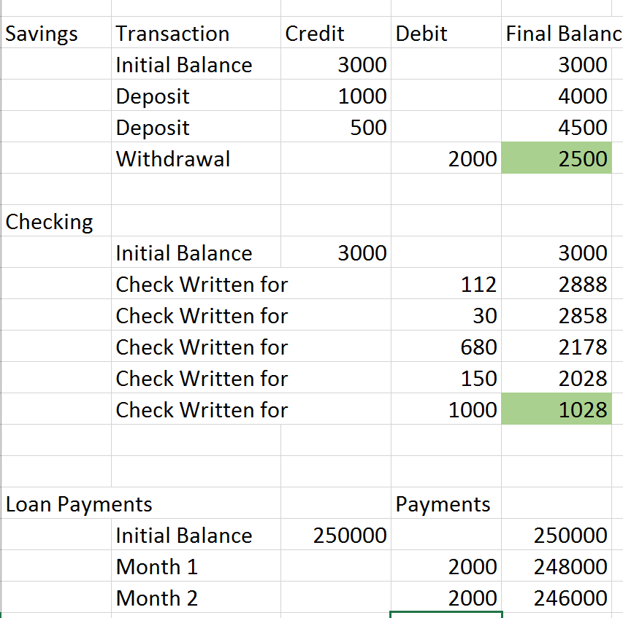

**Output for Savings Account:**

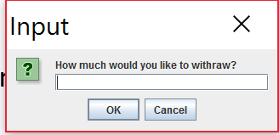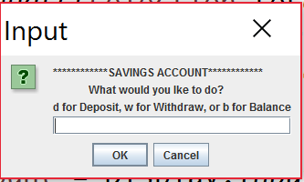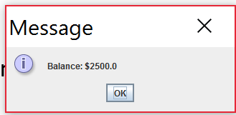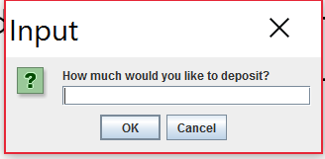

**Output for Checking Account:**

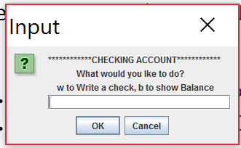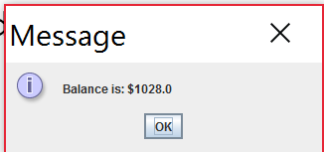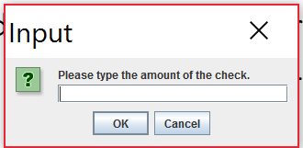

**Loan Payments:**

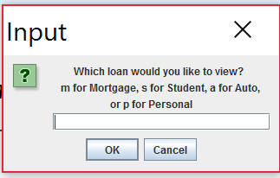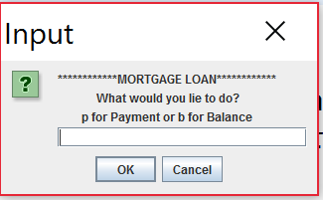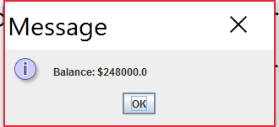

**2 MONTHLY PAYMENTS 🡪**

**\*The rest is just one monthly payment**

